FULL DAY JEEP TOUR ON COFFEE TRAIL
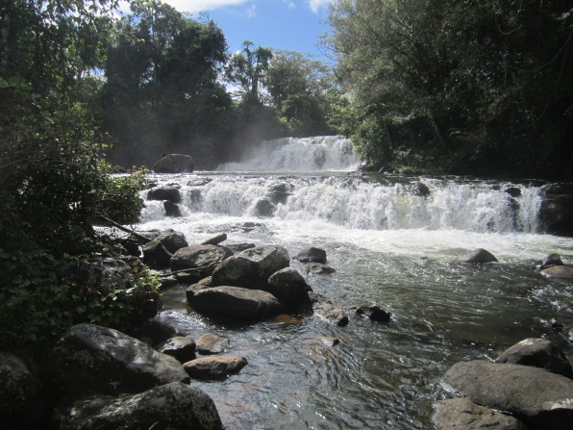

Pakse - Paksong – Tad Moun waterfalls – MMC Coffee farm – Laven and Suay village – Pakse (L)
7h.30 am: Pick up you at the hotel or guesthouse in Pakse
8h.00 am: Departure from Pakse by Car or Minivan then driving directly to Paksong
9h.00 am: Arrival at Paksong stop for Car changing at: Green volcano coffee
and break for a cup of coffee (30minutes). Coffee is FOC for the clients.
10h.00am: Visit Tad Moun waterfall and vegetable fields.
11h.00am: Continue driving 1hrs to MMC Coffee farm on the bumpy + muddy road
(in raining season)
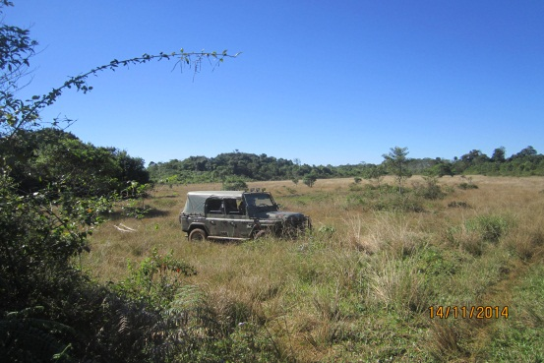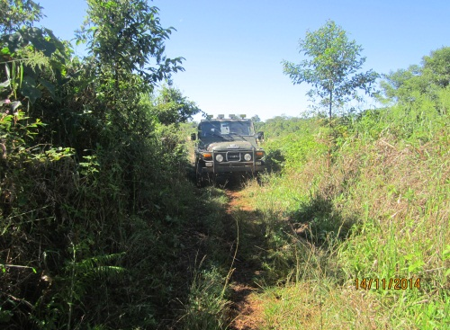
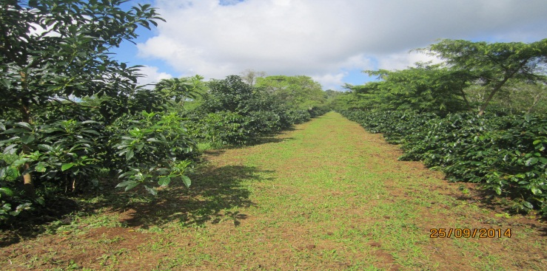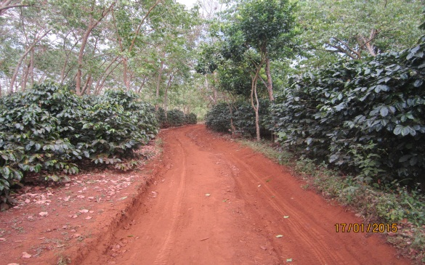

12h.00pm: Arrival at MMC Coffee farm and lunch (fruits, coffee and tea be provided)
1h.00 pm: Mr khamsone will take 1hrs to demonstration about coffee Roasting steps and finishing by a coffee testing to savor the different kind of coffee (Robusta, Arabica and Typica).
2h.00 pm: Continue driving to Laven village

3h.30 pm: Arrival at Laven village and visit there agriculture, culture, and their livelihood.
4h.00 pm: Continue driving 30minutes to Suay village and visit the traditional houses
This village 30% of houses are traditionally built houses made by bamboo
and 60% are only built traditional houses that held several generations of
families. The house is generally one room is used for cooking,eating andsleeping.

6h.30 pm: Arrival at Pakse and transfer to your Hotel and end of service !

Tour Price per person :
All Rates are net in USD:
Rates are per person in a party of:
3 pax | 4 - 6 pax | 7-9 pax up
70 USD/pax | 60 USD/pax | 50 USD/pax

Tour included: What to bring:
- Transportation as mentioned - Swimming clothes
- Mosquito repellent - Sun-cream
- Rain coat - Hat
- Drinking water
- Meals
- English speaking guide
- Coffee and tea

